WOLT PROJECT | Version: 1.0
Test Plan  Project Documentation | Date: 24/07/22
This document provides an overview of the project and the product test strategy, a list of
testing deliverables



Revision History
Date | Version | Description | Author
24/07/22 | 1.0 | Document create | Sergei Boiko

Private & Confidential

CONTENTS
1.Introduction 3
1.1 Background 3
1.2 Test Objectives 3
1.3 Scope testing 3
1.4 Out of scope testing 5
2. Test Artifacts 5
3. Test STRATEGY 6
4. Tools 6
5.Resources 6
5.1.Human Resources 6
5.2.System Resources 7
6. Schedule and estimation 7
7. Test Environment 8
8. Risks Analysis 8
9. Approvals 9
9.1.Metrics 9

Introduction
The objective of this document is to test the functionality of the WOLT application.
The plan specifies the elements to be tested, the functions to be tested, the types of testing to be performed, the personnel responsible for testing, the resources and schedule needed to complete testing, and the risks associated with the plan.

1.1 Background

Wolt makes it incredibly easy to discover and get great food, groceries and anything you might need delivered in your city.

1.2 Test Objectives
The Wolt application available on the official website https://wolt.com on Google Play for Android and App Store for iOS system. We should test application on both devices:
Android APP: https://play.google.com/store/apps/details?id=com.wolt.android
iOS APP: https://apps.apple.com/fi/app/wolt/id943905271

1.3 Scope testing
Functionality testing via black box method.

Module | Role | Description
Login module | User | User have the ability to login via Google account, Facebook account, Email or Guest access
Login module | User | User should check the email confirmation
Location choose | User | User have the ability to choose country with delivery support
Address confirmation | User | User have the ability to auto locate his address or add manually
Restaurant/ Market module | User | User can use offers from famous restaurants
Restaurant/ Market module | User | User can choose category of products
Shop module | User | User can see description of market (rate, working hours, delivery time)
Shop module | User | User can use search system
Shop module | User | User can choose popular/new/category of products
Shop module | User | User can choose the products from menu
Shop module | User | User can choose quantity of product
Shop module | User | User have the ability to choose receive the order method (delivery/takeaway)
Search module | User | User have the ability to choose products tags for fast search or use search bar
Profile module: | User | User have the ability to write name/surname and confirm the term of use
Profile module: | User | User should add the phone number and confirm it with SMS code
1. Token system | User | User have the ability to use tokens for order
2. Bonus system | User | User have the ability to use bonus system: invite friends and get bonuses, promo-codes.
3. Favorites/Likes module | User | User have the ability to add likes for favorite markets
4. Support system | User | User have the ability to use support management
5. Orders history | User | User have the ability to check all his orders
6. Payment system | User | User can choose other payment methods (cash/card)
Order confirmation | User | User have the able to check the order, edit the order, confirm payment method, choose contactless delivery, send comments for order, use bonus/discount system, confirm order.
Rating system | User | User can rate the service after receiving the order
Installation testing | User | User have the ability to download and install/uninstall the application to device

1.4 Out of scope testing

Nonfunctional testing such as:

Stress testing

Performance testing

Security testing

Localization testing

Database testing

Resource utilization testing

Recoverability testing

Failover testing

Scalability testing

Volume testing

Concurrency testing

- Test Artifacts

Test Cases - Test Cases will be submitted during the test design phase.
Bug Report - Bug Report will be shared at the end of each day throughout the test execution cycle.
Test Summary Report - Report will be submitted at the end of testing.

- Test Strategy

Functional testing levels via black-box technique.
Since Wolt application has already been released, we will test it by user acceptance testing level.
Completion Criteria:
- All planned modules have been tested.
- All identified defects have been addressed.
- Tools

The following tools will be employed for this project:

Title | Tool
Test Management | Jira Software
Defect Tracking | Jira Software
Project Management | Jira Work Management

- Resources

  - Human Resources

Project Manager - provides management oversight: 1 member
- Manage the whole project
- Define project directions
- Acquire appropriate resources

Test Designer - identifies, prioritizes, and implements test cases - 1 member
Responsibilities:
- generate test plan
- generate test model
- evaluate effectiveness of test effort

QA specialists - executes the tests - 2 members
Responsibilities:
- execute tests
- log results
- report the defects
- document change requests

  - System Resources
For testing a mobile device application, we should plan the resources as following tables:

Server:
- This includes an application server and database server
Test tool:
- Jira Software - the testing tool is for generate test cases, simulate the user operation, gather the test results
Network:
- You need a Network include LAN and Internet line with the speed at least 5 Mb/s
Devices:
- The mobile devices with Android and iOS system with able to connect via mobile data and Wi-Fi module. Enabled with Google Play on Android and App Store on iOS.

- Schedule and estimation

Start date: 27/07/22

End Date: 03/08/22

Task | Members | Estimate effort
Create the Test Cases | Test Designer | 16 man-hour
Perform Test Execution | QA specialists | 8 man-hour
Test Report | QA specialists | 8 man-hour
Test Delivery | QA specialists | 8 man-hour
Total |  | 40 man-hour

- Test Environment

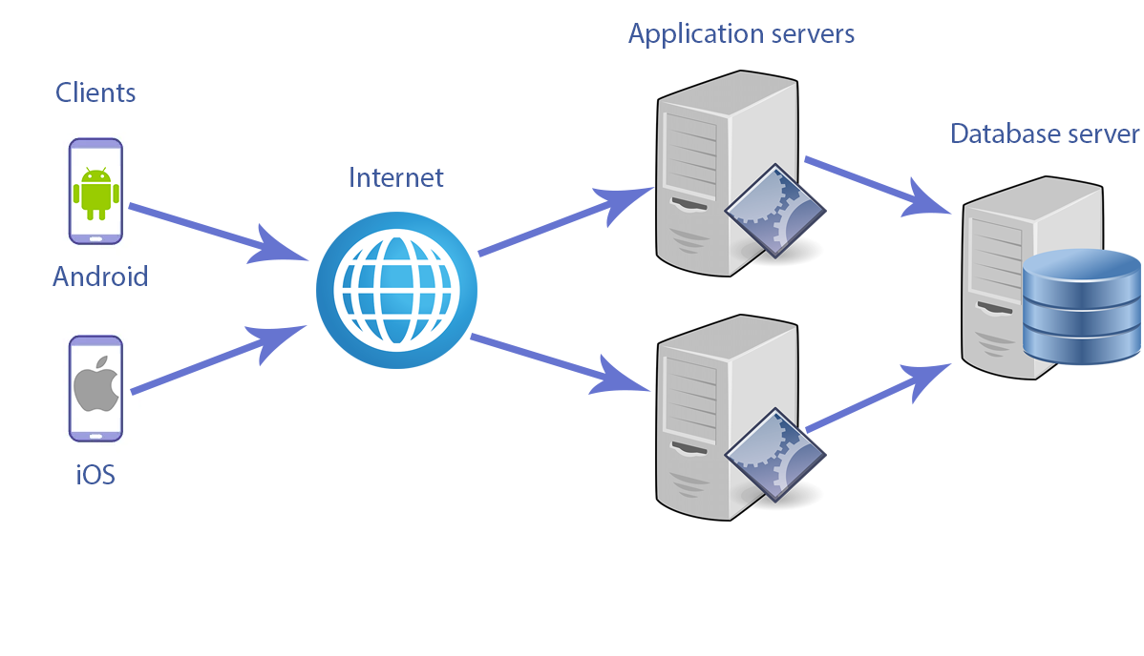

- Risks Analysis

Risk | Mitigation
Lack of required skills within the team. | Plan training course to skill up members
The project schedule is too tight; it’s hard to complete this project on time | Set Test Priority for each of the test activity.
Test Manager has poor management skill | Plan leadership training for manager
A lack of cooperation negatively affects your employees’ productivity | Encourage each team member in his task, and inspire them to greater efforts. Daily meetings and corporate events
Vacation of team members | Plan vacation in advice according to a roadmap.
A team member decides to quit. | Bonus motivation. Regular review 1 by 1. Open position (HR).  Add another specialist if possible.
A team member get sick. | Ask another specialist for part-time work.
Lack of resources | Have additional devices on Android/iOS system
Lack of internet connection | Have the able to connect to others wireless/internet hotspots

Approvals

Project manager should agree on completion of the project and determine the steps to proceed further.
The exit criteria are the targeted results of the test and are necessary before proceeding to the next phase of development.
Acceptance criteria:
100% success of test cases;
90% of all critical path test cases must pass.

9.1 Metrics
- Test cases success percentage:
- T ^{sp}=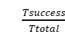 * 100%, where
𝑇^{𝑆𝑃} – percentage of successfully passed test cases,
𝑇^{𝑆𝑢𝑐𝑐𝑒𝑠𝑠} – quantity of successfully passed test cases,
𝑇^{𝑇𝑜𝑡𝑎𝑙} – total quantity of executed test cases.

